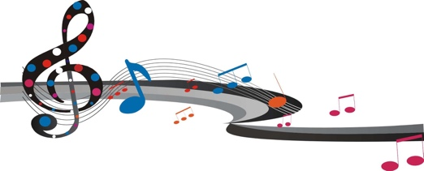
The Classical Road Show
President: Dame Cleo Laine
Vice Presidents: Lady Brewer,Katy Derham
Sir Roger Gifford, Ian Maclay,
Professor Michael Mainelli
Chairman: Adrian Watney
Musical Director Emeritus: Hilary Davan Wetton
Musical Director & Conductor: Benjamin Pope

Founded 1988: Registered Charity No. 1017635 in 1993: www.classicalroadshow.org

Corporate Donation Form

Benefits of sponsoring The Classical Road Show:-

- High impact branding and loyalty factor
- your name on concert fliers sent to hundreds of schools, government music hubs, ministers and VIPs
- your name in concert programmes, given free to thousands of children, families, schools,
local dignitaries, musicologists and other VIP guests

- Perceived as benefactor to musical education at its best
- mention in national and local press releases and concert reviews
- your Logo on our web site, with links to your own web site, as sponsor

- Benefitting youth and music
- Never before has it been so necessary to counter the neglect of music in schools, where it is increasingly marginalised, in spite of recognition of its powerful stimulus to breed success across the board.

- Take it personally!
Sort out the world over tea with the Conductor and Concert Principals after the Show

Optional Sponsorship Packages (please indicate your preference):-

• £12,000 - £16,000: Concert with Symphony Orchestra, narrators and schools’ massed choirs

• £3,000 – Annual Twilight Teachers’ Workshops in 3 centres: Hammersmith, Croydon, Barbican

• £2,000 - Front Row Club project for secondary schools

• £3,500 - Proposed ‘Young Composers’ Hotline’ for primary schools

• £1,500 pa for three years - Web home-page sponsorship

• £500 / £300 - Concert programme advertising of full page / half page

• £20,000 - New Commission of concert piece (dedication in perpetuity)

• Donation of any amount £_ _ _ _ _ _
All donations will be gratefully acknowledged in the concert programmes.

I would like to make a donation to The Classical Road Show of £___________

Name of Company: ____________________________________________________

Name of Contact: __________________________Email: ________________________________

Address:________________________________________________________________________

_______________________________________________________________________________

Please either return this form and your cheque payable to The Classical Road Show to:
Meddie Wang, Hon Treasurer, The Classical Road Show, Flat 26, Evelyn Mansions, London SW1P 1NY

Or pay by bank transfer to The Classical Road Show account, sort code 16 20 30, a/c no 10193905,
reference, your company name and either post this form to Meddie Wang as above
or email it to her at treasurer@classicalroadshow.org Thank you!

