# 

# The Classical Road Show

# is delighted to invite pupils aged 7-11yrs to take part in their

***Zambezi Tales* Concert: Monday 18 October 2021**

# Milton Court, Barbican : performances at 11.15am & 1.30pm lasting one hour

***with* The London Mozart Players and Guildhall School of Music players**

**narrators Annabelle Brown, Clive Rowe and Rosalie Craig: conductor Benjamin Pope**

**A rare musical theatre experience performed by professional & student orchestras side-by-side, actors**

**and YOUR PUPILS singing throughout from their audience seat**

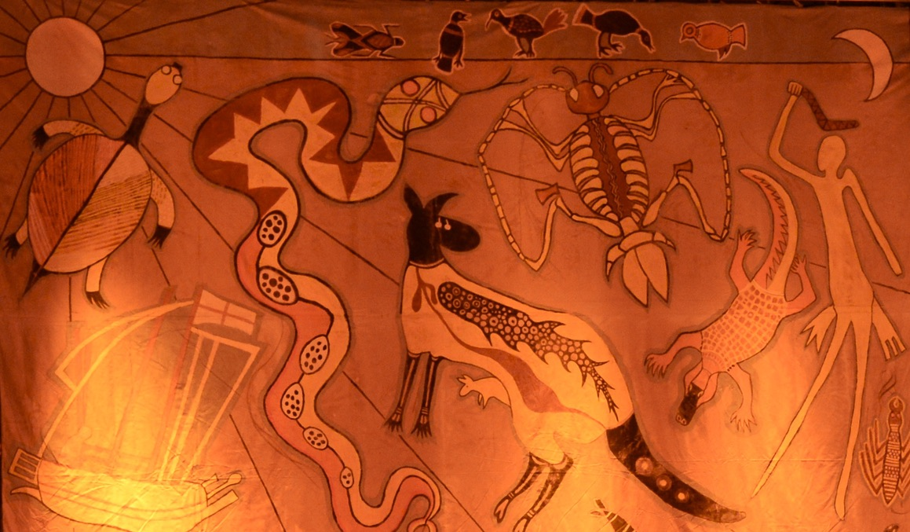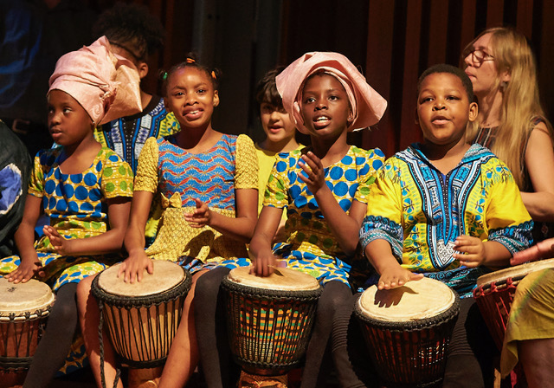

**We hope that you and your children will come and enjoy taking part in Zambezi Tales, written especially for Classical Road Show concerts by Richard Brown (composer) and Nigel Williams (words).**

**These African folk tales, handed down by many successive generations, are from Zimbabwe and Zambia, mostly from the Shona and Tonga tribes. Some tales are funny and some are fierce. They will be related and sung by our narrators, with all our schools joining in the audience songs.**

**Please note our optional Art Project www.classicalroadshow.org, which encourages dressing up!**

***__________________________________________________________________________________________________________________________________________________________________________________________________________***

**The Classical Road Show booking / payment form for**

**ZAMBEZI TALES concert in MILTON COURT, BARBICAN**

**18 October 2021 at 11.15am or 1.30pm**

***Tickets £5. Concerts last for one hour.***

**STAFF CONTACT: ………………………………………………...........POSITION: …………………………..……Date ……………….**

**SCHOOL: ………………….…..………….…………… ……………………… ADDRESS: …………………………….………….…………….**

**………………………………………………………………………………………………………….…………………………….……………………….**

**Email: ………………………………………….…………....……………… Tel/ Mob ……………………..…………………………………….**

**We would like to book**

**______ Conductor-led Workshop for teachers (optional & free) in Guildhall School of Music, 6 Sept 2021, 4 - 5.00pm**

**______ Concert tickets @ £5 for children & accompanying adults for 11.15am OR 1.30pm performance *(please indicate which)***

***Please email us separately about our Hardship Fund, if some of your children have difficulty paying for tickets.* Disabled access required? Y/N**

*Please tick one of these three PAYMENT options:-*

* **Please find enclosed our cheque** for £_______ **payable to The Classical Road Show** *OR:*
* **We have made a BACS transfer of £__________into The Classical Road Show account Date: _______________**

**RBS sort code: 16 20 30 account no: 10193905 ref: your school name**  *OR***:**

* **We will pay by 9 July 2021 (or at latest by 9 September, by special arrangement.)**

**The Classical Road Show will refund all ticket money if they cancel the concert.**

**Please post or email this form to**

**Sheila Bennett, The Classical Road Show, Heath Farmhouse, Heath Lane, Godalming, Surrey GU7 1UN**

**Email: concerts@classicalroadshow.orgFor enquiries, please email or telephone 07827 679115 or 07941 683115**